**Other Sponsorship or Donation Opportunities:**

* Breakfast
* Beverage (water, soda pop)
* Beverage (beer)
* Lunch (hamburgers and buns)
* Lunch (sausage)
* Lunch (hot dogs and buns)
* Snacks (chips, nuts, crackers)
* Dessert
* Prizes
* Gift Certificates
* Other

My Choice of Law Enforcement Officer is:

(If you do not have a LE choice, one will be placed on your team)

Player 3/Email:

Player 2/Email:

Player 1/Email:

Company/Contact/phone and Email:

Chosen Sponsorship:

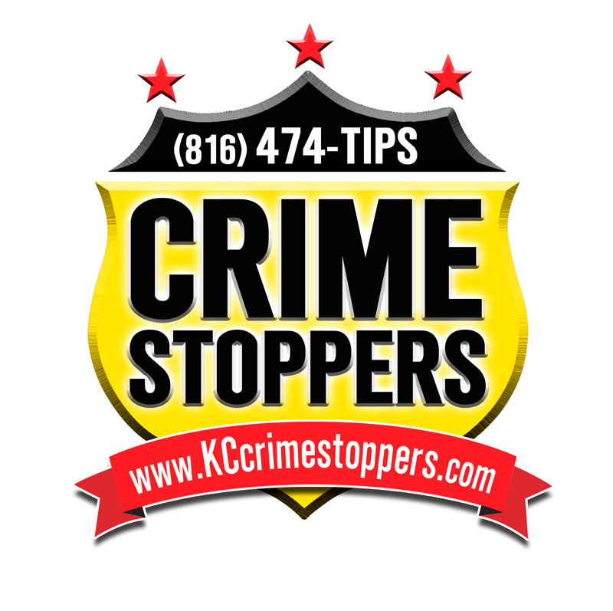

**816-474-TIPS**

**23rd ANNUAL CRIME STOPPERS TIPS HOTLINE GOLF CLASSIC**

**\* CELEBRATE THE SCHEDULED SOLAR ECLIPSE ON THE GOLF COURSE WITH CRIME STOPPERS!**

**Monday, August 21st, 2017**

**Oakwood Country Club**

**9800 Grandview Rd**

**Kansas City, MO 64137**

PRESENTING SPONSORS:



I am unable to provide sponsorship; however, would like to support Crime Stoppers. Please find my check enclosed for the amount of:

(Discover, Mastercard & Visa also accepted)

**GAME PACKAGE:**

Sponsors can purchase a game pass for entire team for $100.00. This will give team one entry to every on-course game. Just indicate below whether you want this option and please add $100 to sponsorship level when sending in payment. Entries can be purchased the day of the event also.

Yes, I would like to purchase game package for $100.00.



**$8,000 Tournament Presenter – American Century Investments**

**Company name and logo prominently displayed throughout tournament. Three additional player spots, one additional law enforcement player spot, reserved table with signage and preferred seating at banquet and six additional guests at banquet.**

**$6,000 Banquet Sponsor**

Company name and logo prominently displayed during banquet and reserved table, signage and preferred seating at banquet.

**$5,000 Signature Merchandise/Apparel Sponsor - QuikTrip**

Company name or logo displayed on major merchandise or apparel item provided to all attendees.

**$3,500 Golf Glove Sponsor**

Company name or logo displayed on all gloves provided to all attendees.

**$3,500 Umbrella Sponsor**

Company name or logo displayed on umbrellas provided to all attendees.

**$2,500 Tote Bag Sponsor**

Company name or logo displayed on reusable bags provided to all attendees.

**$2,500 Ammunition Sponsor (Golf Balls)**

Company name or logo displayed on golf balls provided to all attendees.

**$2,500 Fingerprint Sponsor (Bag Tags)**

Company name or logo displayed on bag tags provided to all attendees.

**$2,500 Ditty Bag Sponsor**

Company name or logo displayed on storage bags provided to all attendees

**$2,500 Trophy Sponsor**

Company name or logo displayed on trophies presented to winning teams.

**$2,500 Squad Car Sponsor (Golf Carts)**

Company name and logo prominently displayed on all player golf carts.

**$2,500 Hospitality Sponsor (Volunteer Carts)**

Company name and logo prominently displayed on all volunteer carts.

**$2,500 Booking Desk Sponsor**

Company name or logo displayed at Check-In table.

**$2,500 Driving Range Sponsor**

Company name or logo prominently displayed at the driving range.

**$2,500 Putting Green Sponsor**

Company name or logo prominently displayed at the putting green.

$1,500 Hole Sponsor

Company name or logo will be displayed at one hole. Media release recognition not included.

$500 Individual Player

Includes green fees, cart, breakfast, favors, prizes, team photo, drinks, lunch and banquet.



**23rd**

**ANNUAL CRIME STOPPERS TIPS HOTLINE GOLF CLASSIC**

**2017 All Sponsorships opportunities include the following unless otherwise noted:** 3 reserved player spots with one Law Enforcement player choice with green fees, carts, breakfast, favors, prizes, team photo, drinks for the day, lunch, dinner banquet and awards and recognition in banquet program, on website and in media releases.

**TOURNAMENT SCHEDULE:**

**7:30am** – Registration, Putting Contest, Warm Up

**9:00am** – Shotgun Start, Tournament Begins

**After Golf** – Dinner Banquet/Awards

**4 PERSON SCRAMBLE**

**Contact for more information:**

Kendra Meeker

816-960-6800 ext 228

[kmeeker@kc-crime.org](mailto:kmeeker@kc-crime.org)

www.kccrimestoppers.com

**Game Sponsorships available also at $500:** Game Sponsorships include company name displayed at contest: **players/team not included.** Examples of contests:

* Closest to the Pin
* Go for the Ace
* Putting Contest
* And many more!!

**Send Payment and Player Information to:**

**Kansas City Crime Commission**

**3100 Broadway, Suite 226**

**Kansas City, MO 64111**

(Discover, Mastercard & Visa also accepted)

(All sponsorships are sold on a first come first served basis, with date of your check resolving any questions.)