
CrimeStoppers
NEEDS YOUR HELP

D

Help us solve this case…
Town of Boonton Police Department
We are seeking assistance in the apprehension of the below pictured male: Carlos E. Paguada
Also Known As “Los”

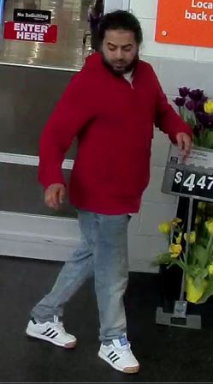

Carlos is a 28 year old Hispanic male,
5’02” in height, weighs 150 lbs, with brown eyes, long black hair and a full beard.
He was last seen wearing a red colored hooded sweatshirt, blue jeans and white Adidas sneakers with brown tips, riding a white and blue BMX style bicycle with pegs.

WANTED FOR
AGGRAVATED ASSAULT w/ a DEADLY WEAPON
POSSESSION of WEAPONS for UNLAWFUL PURPOSE
UNLAWFUL POSSESSION of WEAPON

Carlos may be armed and dangerous – Call 9-1-1 if you come into contact with him.
We are asking anyone that may have information to contact
The Morris County Sheriff’s CrimeStoppers at: www.copcall.org
973-COP-CALL or
Use the free “P3 Tips” app on any mobile device

NO ONE WILL ASK YOUR NAME!
YOU could receive a REWARD up to $1,000.00

