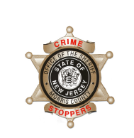
CrimeStoppers
NEEDS YOUR HELP

D

Help us solve this case…
Dover
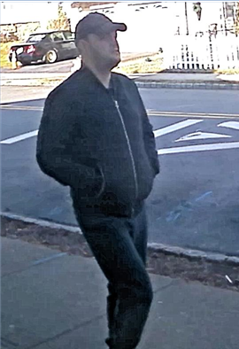
On Wednesday, December 26, 2018, the Dover Police Department responded to 64 King Street, Dover, NJ for a structure fire. The Dover Police Department and the Morris County Prosecutor’s Office Fire/ Environmental Unit have determined the fire to be suspicious. Above is a person of interest, the Dover Police Department and the Morris County Prosecutor’s Office is seeking any information that identifies the individual above or leads to the arrest of a suspect.
We are asking anyone that may have information to contact
The Morris County Sheriff’s CrimeStoppers at: www.copcall.org
973-COP-CALL or
Use the free “P3 Tips” app on any mobile device

NO ONE WILL ASK YOUR NAME!
YOU could receive a REWARD up to $1,000.00

